Superstar karaoke APP

SUPERSTAR APP RROJECT

|  |  |
| --- | --- |
| **Prepared by:** | Yagyani |
| **Prepared for:** | Superstar |
| **Current Version:** | V1.0 |
| **Ref No.:** | TC/SS/20230621 |
| **Document Name** | Superstar FRD |
| **Author:** | Yagyani |
| **Date Created:** | 22nd August 2023 |
| **Date Submitted:** | 22nd August 2023 |
| **Approved By:** | Naman Narayan |
| **Approval Date:** |  |

**Revision History:**

|  |  |  |  |
| --- | --- | --- | --- |
| **Version Number** | **Brief Description of Changes** | **Revision Author** | **Date Updated** |
| V1.0 | Requirement Gathering | Yagyani | 18th July 2023 |
| V1.1 |  |  |  |
| V1.9 |  |  |  |
| V2.0 |  |  |  |

**Document Approvals History:**

|  |  |  |  |
| --- | --- | --- | --- |
| **Version Number** | **Name** | **Signature** | **Date** |
| V1.0 | Naman Narayan |  |  |
|  |  |  |  |
|  |  |  |  |

Table of Contents

1. Introduction 7

Project Objectives 7

2. Statement of work 7

2.1. Mobile App 7

2.2. Users & Access 7

3. Software Requirements 7

Daily Task 7

Introduction 7

Background 7

Customer Research 7

Release 7

Requirements 7

Data Parameters 7

Questions 7

Not Doing 7

User Interface & Design 7

Games 7

Introduction 7

Background 7

Customer Research 7

Release 7

Requirements 7

Data Parameters 7

Questions 7

Not Doing 7

User Interface & Design 7

My Live 7

Introduction 7

Background 7

Customer Research 7

Release 7

Requirements 7

Data Parameters 7

Questions 7

Not Doing 7

User Interface & Design 7

Recharge 7

Introduction 7

Background 7

Customer Research 7

Release 7

Requirements 7

Data Parameters 7

Questions 7

Not Doing 7

User Interface & Design 7

My songs 7

Introduction 7

Background 7

Customer Research 7

Release 7

Requirements 7

Data Parameters 7

Questions 7

Not Doing 7

User Interface & Design 7

Wallet 7

Introduction 7

Background 7

Customer Research 7

Release 7

Requirements 7

Data Parameters 7

Questions 7

Not Doing 7

User Interface & Design 7

Gifts 7

Introduction 7

Background 7

Customer Research 7

Release 7

Requirements 7

Data Parameters 7

Questions 7

Not Doing 7

User Interface & Design 7

Achievement 7

Introduction 7

Background 7

Customer Research 7

Release 7

Requirements 8

Data Parameters 8

Questions 8

Not Doing 8

User Interface & Design 8

Documentation

|  |  |  |
| --- | --- | --- |
| Documentation Type | Description | Note |
| Product Requirement Document | Please see this documentation |  |
| User Experience Design documentation | User Experience Design documentation begins at the requirements stage and proceeds through all the stages of development, including the testing and post-release stages. The process of UX design includes research, prototyping, usability testing, and the actual designing part, during which lots of documentation and deliverables are produced |  |
| System Design | **Overview and background:** Briefly describe the main goals of the project, what problems you are trying to solve, and the results you want to achieve.  **Architecture & Design Principles:** Underline the guiding architecture and design principles with which you will engineer the product. For instance, if you plan to structure your solution using microservices architecture, don’t forget to specifically mention this.  **User Story description.** Connect user stories with associated business processes and related scenarios. You should try to avoid technical details in this section.  **Solution details.** Describe the contemplated solution by listing planned services, modules, components, and their importance.  **Diagrammatic representation of the solution.** Provide diagrams and/or other graphic materials to help understand and communicate the structure and design principles. |  |
| Source Code Document | A source code document is a technical section that explains how the code works. While it’s not necessary, the aspects that have the greatest potential to confuse should be covered. The main users of the source code documents are software engineers.  Source code documents may include but are not limited to the following details:   * HTML generation framework and other frameworks applied. * type of data binding. * design pattern with examples (e.g., model-view-controller). * security measures; and * other patterns and principles.   Try to keep the document simple by making short sections for each element and supporting them with brief descriptions. |  |
| QA Documents | * The test case ID * Test case description * Prerequisites * Test steps * Test data * Expected result. * Actual result * Status * Created by * Date of creation * Executed by * Date of execution |  |
| API Document | User Reference of Stripe or Twilio or any other big company |  |

Platform Technology

Frontend

|  |  |  |
| --- | --- | --- |
| **Technology** | **Version** | **Comments** |
| React Native | 0.59 |  |
| JavaScript | ECMAScript |  |

Backend

|  |  |  |
| --- | --- | --- |
| **Technology** | **Versions** | **Comments** |
| NodeJS | 18.16.0 |  |
| MySQL | 8.0.2 |  |
| Postman | 9.4 |  |
| REST API |  |  |

# Introduction

Begin by introducing the project or application for which the FRD is being prepared. Provide a concise summary of the application's purpose and its main functionalities.

Specifically, for the profile module of the Star Maker app in this context, describe its purpose and significance within the app. Mention the module's main features and the value it adds to the overall user experience.

State the objectives of the profile module. This may include enhancing user engagement, facilitating connections between users, providing a personalized experience, and any other relevant goals.

# Project Objectives

**Profile**- Daily Task/Games/My Live/Recharge/My Songs/Wallets/Gifts/Achievements.

Encourage users to actively participate and interact within the app through personalized profiles, fostering a sense of community. Enable users to connect, follow, and engage with each other through likes, comments, and messages, promoting social interactions. Allow users to customize their profiles with pictures, bios, and background music, creating a unique and expressive identity. Empower users with control over profile visibility and privacy settings for a safe and trusted environment. Implement badges or achievements based on user activity to motivate and reward active participation.

# Statement of work

### Mobile App

1. User Profile

### Users & Access

#### General

|  |  |  |  |
| --- | --- | --- | --- |
| Users | User Information | User Performances | User Subscription |
| Management Team | Access | Access | Access |
| Users | Access | Access | Access |

#### Roles

* User

|  |  |  |  |  |  |  |
| --- | --- | --- | --- | --- | --- | --- |
| Modules | Create | Edit | Update | Delete | Export | Records |
| User Information | Access | Access | Access | No Access | No Access | Own |
| User Performances | Access | Access | Access | No Access | No Access | Own |
| User Subscription | Access | Access | Access | Access | No Access | Own |

# Software Requirements

## Daily Task

### Introduction

The Daily Task module within the "Superstar" karaoke music app is designed to enhance user engagement by providing a set of tasks that users can complete daily. By completing these tasks, users earn experience points (XP) which contribute to leveling up their app profile. This gamified approach encourages users to actively participate in the app and strive for continuous improvement.

### Background

To keep users engaged and motivated within the "Superstar" karaoke music app, it's essential to provide a dynamic and rewarding experience. The Daily Task module aims to accomplish this by offering a range of tasks that cater to various user preferences and skill levels. As users complete these tasks and claim their experience rewards, they not only enhance their app experience but also contribute to the overall sense of achievement within the app's community.

### Customer Research

None

### Release

|  |  |
| --- | --- |
| Target Releases | 1.0 |
| Epic | Singing |
| Document Status | Draft |
| Document Owner | Yagyani |
| Designer | Sharvil |
| Developer | Meru & Deepak |
| QA | Yagyani |

### Requirements

|  |  |  |  |  |
| --- | --- | --- | --- | --- |
| # | User Story | Description | Priority | Notes |
| 1 | Completing Daily Tasks | As a user of the "Superstar" karaoke music app, I want to have access to a set of daily tasks that I can complete to earn experience points (XP) and increase my app level. |  | * Users should be presented with a list of diverse tasks that cater to different app interactions. * Each task should have an associated XP value that reflects its complexity or engagement level. * Once I complete a task, the corresponding XP should be added to my profile. * There should be an intuitive way to track my progress toward completing daily tasks. * Completing daily tasks should contribute to enhancing my overall app level. |

### Data Parameters

|  |  |  |  |  |
| --- | --- | --- | --- | --- |
| Fields | Type | Variables | Note | Properties |
| Task | Task | task | Represents an individual task within the Daily Task module. | ID (unique identifier), Title (task title), Description (detailed task description), XPValue (experience points rewarded), Status (completed/incomplete), RewardClaimed (whether the XP reward has been claimed). |
| User | User | user | Represents a user of the "Superstar" karaoke music app. | ID (unique identifier), Username (user's username), Level (user's app level), Experience (total experience points earned), TasksCompleted (list of completed tasks), RewardsClaimed (list of claimed XP rewards). |

### Questions

Below is a list of questions to be addressed because of this requirements documents:

|  |  |
| --- | --- |
| Question | Outcome |
|  |  |
|  |  |
|  |  |

### Not Doing

### User Interface & Design

Exact user interface and design is available at <https://www.figma.com/proto/IiJCR9f39xj60n11HOALMY/Music-karaoke-app?type=design&node-id=2213-36973&t=hdzgbbJMqXOFXzsI-0&scaling=scale-down&page-id=6%3A3887&starting-point-node-id=2213%3A22310>

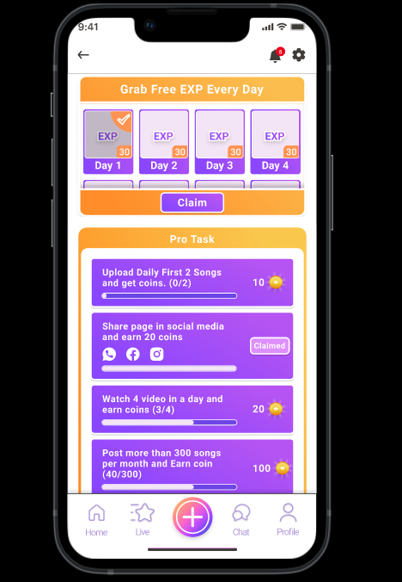

## Games

### Introduction

The Games module within the "Superstar" karaoke music app offers users an array of engaging and user-friendly games designed to provide entertainment and interaction beyond karaoke performances. This module aims to enhance user engagement and enjoyment within the app ecosystem.

### Background

With a focus on delivering a comprehensive entertainment experience, the "Superstar" app introduces the Games module. This module is intended to cater to users seeking additional avenues for engagement while maintaining the app's core karaoke functionalities. By incorporating entertaining and easy-to-understand games, the "Superstar" app aims to diversify user interactions and provide moments of leisure within the app's environment.

### Customer Research

None

### Release

|  |  |
| --- | --- |
| Target Releases | 1.0 |
| Epic | Singing |
| Document Status | Draft |
| Document Owner | Yagyani |
| Designer | Sharvil |
| Developer | Meru & Deepak |
| QA | Yagyani |

### Requirements

|  |  |  |  |  |
| --- | --- | --- | --- | --- |
| # | User Story | Description | Priority | Notes |
| User Story 1 | Discover and Play Games | As a user of the "Superstar" app, I want to discover and play a variety of interesting and accessible games to have a more enjoyable and engaging experience. |  | * Users should be able to easily navigate to the Games section from the app's main menu. * The Games section should prominently display a diverse selection of games. * Each game should have a brief description, providing an understanding of the gameplay. * Games should be designed to cater to users of all skill levels. |
| User Story 2 | Access Game Rules and Tutorials | As a user exploring the Games module, I want clear and concise explanations of each game's rules and mechanics to ensure I can play them effectively. |  | * Each game should have an accessible "How to Play" section or tutorial. * The tutorial should provide step-by-step instructions and visual aids if necessary. * Users should be able to access the tutorial from within the game interface. |
| User Story 3 | Track and Display High Scores | As a competitive user, I want to see my high scores for each game so that I can compare my performance with others and strive to improve. |  | * Each game should display the user's personal high score. * Users should be able to view the high scores of other players as well. * High scores should be updated in real-time to maintain competitiveness. |

### Data Parameters

|  |  |  |  |
| --- | --- | --- | --- |
| Fields | Type | Variables | Note |
| Cover Picture | Game | gameName, gameDescription | Represents an individual game within the Games module. |
|  | GameScore | highScore | Stores the user's high score for a specific game. |
|  | Tutorial | tutorialContent | Contains information about how to play a game. |

### Questions

Below is a list of questions to be addressed because of this requirements documents:

|  |  |
| --- | --- |
| Question | Outcome |
|  |  |
|  |  |
|  |  |

### Not Doing

### User Interface & Design

The exact user interface and design is not develop yet and no wireframe is available.

## My Live

### Introduction

The "My Live" module is a pivotal component of the "Superstar" karaoke music app, designed to provide users with valuable insights and statistics regarding their live performances and interactions within the app. This module aims to enhance user engagement, help them track their progress, and foster a sense of community among users by highlighting their live experiences.

### Background

As karaoke enthusiasts actively engage with the "Superstar" app's live performances, it becomes imperative to offer them a comprehensive overview of their live sessions. This module serves as a performance dashboard, presenting data on live duration, income, followers, and gifts. This data empowers users to understand their popularity and interaction trends, contributing to an enriched karaoke experience.

### Customer Research

None

### Release

|  |  |
| --- | --- |
| Target Releases | 1.0 |
| Epic | Singing |
| Document Status | Draft |
| Document Owner | Yagyani |
| Designer | Sharvil |
| Developer | Meru & Deepak |
| QA | Yagyani |

### Requirements

|  |  |  |  |  |
| --- | --- | --- | --- | --- |
| # | User Story | Description | Priority | Notes |
| 1 | Access Live Performance Insights | As a user of the "Superstar" app, I want to access detailed insights about my live performances to understand my live session statistics and engagement metrics. |  | * Users should be able to access the "My Live" section from their profile dashboard. * The insights should encompass live duration, income earned, new followers gained, gifts received, and more. * The data should be visually presented in a user-friendly and comprehensible manner. |
| 2 | Monthly Analytics Overview | As a user, I want to view a monthly analytics overview of my live sessions, providing me with a detailed breakdown of my performance trends and earnings. |  | * The monthly analytics should include income data, gifts received, and number of followers gained for each live session. * A tabular format is recommended to allow users to quickly grasp trends and make comparisons. |

### Data Parameters

|  |  |  |  |
| --- | --- | --- | --- |
| Fields | Type | Variables | Note |
| LiveSession |  |  |  |
| liveDuration | Time | liveDuration | The duration of the live session. |
| validLiveDays | Integer | validLiveDays | The number of days with valid live sessions. |
| liveIncome | Currency | liveIncome | The income earned from live performances. |
| newFollowers | Integer | newFollowers | The number of new followers gained during live sessions. |
| giftsReceived | Array | giftsReceived | A list of gifts received during live performances. |
| incomeAnalytics | Array | incomeAnalytics | A structured array containing monthly income analytics. |
| MonthlyAnalytics |  |  |  |
| month | String | month | The name of the month. |
| incomeData | Currency | incomeData | Total income earned during the month. |
| giftsReceived | Integer | giftsReceived | Total gifts received during the month. |
| followersGained | Integer | followersGained | Total followers gained during the month. |

### Questions

Below is a list of questions to be addressed because of this requirements documents:

|  |  |
| --- | --- |
| Question | Outcome |
|  |  |
|  |  |
|  |  |

### Not Doing

### User Interface & Design

Exact user interface and design is not designed yet but a reference design is attached below.

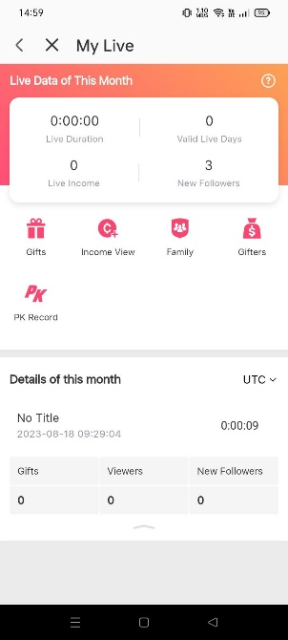

## Recharge

### Introduction

The Recharge module is an integral component of the Superstar karaoke music app, designed to enhance user engagement and provide opportunities for users to enhance their in-app experience through bonus packages and coin packages. This module facilitates seamless transactions for purchasing virtual currency within the app, enabling users to unlock additional features and benefits.

### Background

The Superstar karaoke music app aims to offer a comprehensive entertainment platform for users to engage with music, live performances, games, and social interactions. The Recharge module emerges as a vital part of the app's revenue generation strategy, providing users with the option to purchase bonus packages and coin packages. These packages offer varying quantities of in-app currency, enabling users to access premium features, enhance their virtual presence, and enjoy an elevated karaoke experience.

### Customer Research

None

### Release

|  |  |
| --- | --- |
| Target Releases | 1.0 |
| Epic | Singing |
| Document Status | Draft |
| Document Owner | Yagyani |
| Designer | Sharvil |
| Developer | Meru & Deepak |
| QA | Yagyani |

### Requirements

|  |  |  |  |  |
| --- | --- | --- | --- | --- |
| # | User Story | Description | Priority | Notes |
| 1 | Purchase Bonus and Coin Packages | As a user of the Superstar karaoke music app, I want the ability to purchase bonus packages and coin packages so that I can enhance my app experience and access premium features. |  | * Users should have a straightforward method to access the Recharge module from the app's main interface. * The Recharge module should provide clear details about available bonus packages and coin packages. * Transactions within the Recharge module should be secure and user-friendly. |

### Data Parameters

|  |  |  |  |
| --- | --- | --- | --- |
| Fields | Type | Variables | Note |
| Package | Package | packageDetails | This data type represents the details of a specific package, including its name, value, and associated in-app currency. |
| Transaction | Transaction | transactionInfo | This data type encompasses the information related to a transaction, such as package purchased, transaction date, amount, and payment method. |
| PaymentMethod | PaymentMethod | selectedMethod | This data type stores the user's chosen payment method for the transaction, such as credit card, PayPal, or in-app balance. |
| Currency | Currency | currencyType | This data type specifies the type of in-app currency involved in the transaction, distinguishing between gold coins and blue coins. |

### Questions

Below is a list of questions to be addressed because of this requirements documents:

|  |  |
| --- | --- |
| Question | Outcome |
|  |  |
|  |  |
|  |  |

### Not Doing

### User Interface & Design

Exact user interface and design is available at <https://www.figma.com/proto/IiJCR9f39xj60n11HOALMY/Music-karaoke-app?type=design&node-id=2372-21915&t=hdzgbbJMqXOFXzsI-0&scaling=scale-down&page-id=6%3A3887&starting-point-node-id=2213%3A22310>

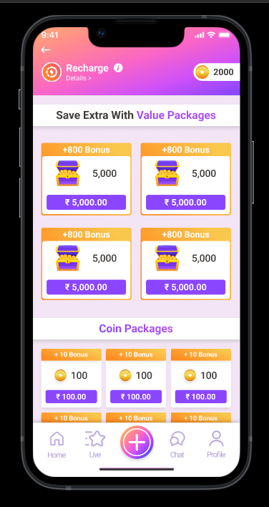

## My songs

### Introduction

The "My Songs" module in the "Superstar" karaoke music app allows users to manage their recorded covers, both solo and duet performances, and draft recordings. Users can easily access and organize their favorite covers, review their personal performances, and work on drafts before publishing them.

### Background

As the "Superstar" app strives to provide an immersive and personalized karaoke experience, the "My Songs" module aims to empower users to curate their recorded performances and drafts in a seamless and organized manner. This feature encourages users to express themselves through music, track their progress, and refine their karaoke skills over time.

### Customer Research

None

### Release

|  |  |
| --- | --- |
| Target Releases | 1.0 |
| Epic | Singing |
| Document Status | Draft |
| Document Owner | Yagyani |
| Designer | Sharvil |
| Developer | Meru & Deepak |
| QA | Yagyani |

### Requirements

|  |  |  |  |  |
| --- | --- | --- | --- | --- |
| # | User Story | Description | Priority | Notes |
| 1 | As a passionate karaoke enthusiast and user of the "Superstar" app, I want a dedicated "My Songs" module, so that I can easily manage, access, and improve my recorded covers and drafts, enhancing my musical journey. | The module should provide a user-friendly interface for smooth navigation and interaction.  Users should be able to distinguish between favorite covers, personal covers, and drafts easily.  Cover recordings should have appropriate metadata, such as title, date recorded, and collaborators for duets. |  |  |
| Favorite Covers |  | * Users can save their favorite solo and duet covers. * Covers should be easily accessible and playable. * Users can quickly search and find specific favorite covers. |  |  |
| My Covers |  | * Users can access and manage their own solo and duet cover recordings. * Playback functionality should be available for self-assessment and enjoyment. * Users can edit or delete their recordings as needed. |  |  |
| Drafts |  | * Users can work on draft recordings before finalizing and publishing. * Drafts should be saved automatically to prevent data loss. * Users can edit, delete, or finalize drafts based on their preferences. |  |  |

### Data Parameters

|  |  |  |  |
| --- | --- | --- | --- |
| Fields | Type | Variables | Note |
| Cover |  |  |  |
|  | Integer | coverID | Unique identifier for the cover recording. |
|  | String | title | Title of the cover recording. |
|  | Time | dateRecorded | Date when the cover recording was created. |
|  | Array of Object | performers | List of performers involved in the cover (for duets). |
|  | file | audioFileURL | URL to the audio file of the cover recording. |
|  | Boolean | isFavorite | Boolean indicating if the cover is marked as a favorite. |
|  | Boolean | isDraft | Boolean indicating if the recording is a draft. |

### Questions

Below is a list of questions to be addressed because of this requirements documents:

|  |  |
| --- | --- |
| Question | Outcome |
|  |  |
|  |  |
|  |  |

### Not Doing

### User Interface & Design

Exact user interface and design is available at <https://www.figma.com/proto/IiJCR9f39xj60n11HOALMY/Music-karaoke-app?type=design&node-id=2213-36725&t=hdzgbbJMqXOFXzsI-0&scaling=scale-down&page-id=6%3A3887&starting-point-node-id=2213%3A22310>

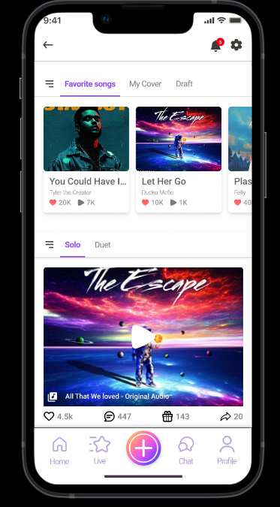

## Wallet

### Introduction

The Wallet module is a crucial component of the "Superstar" karaoke music app, designed to provide users with a comprehensive view of their in-app currency and transaction history. Through the Wallet, users can efficiently manage their gold and blue coins, make purchases, view their transaction records, and track their financial interactions within the app.

### Background

As the "Superstar" app offers a wide array of features and interactions, it's essential to provide users with a transparent and accessible method to manage their virtual currency. The Wallet module addresses this requirement by offering users a consolidated platform to track their coins, buy additional coins, and monitor their financial activities.

### Customer Research

None

### Release

|  |  |
| --- | --- |
| Target Releases | 1.0 |
| Epic | Singing |
| Document Status | Draft |
| Document Owner | Yagyani |
| Designer | Sharvil |
| Developer | Meru & Deepak |
| QA | Yagyani |

### Requirements

|  |  |  |  |  |
| --- | --- | --- | --- | --- |
| # | User Story | Description | Priority | Notes |
| 1 | Manage In-App Currency and Transactions | As a user of the "Superstar" app, I want to have a convenient and clear way to manage my virtual currency (gold and blue coins). I also want to be able to view my transaction history to keep track of how I've received and spent coins. |  | * The Wallet should prominently display my current total of gold and blue coins. * I should be able to see a breakdown of received and spent coins. * I need the ability to buy additional coins directly from the Wallet module. * The transaction history should list the details of each coin-related transaction. |

### Data Parameters

|  |  |  |  |
| --- | --- | --- | --- |
| Fields | Type | Variables | Note |
| WalletData |  |  |  |
| Total Gold coins | integer | totalGoldCoins | Stores the total count of gold coins in the user's wallet. |
| Total blue coins | integer | totalBlueCoins | Stores the total count of blue coins in the user's wallet. |
| Received Coins | array of objects | receivedCoins | Records each instance of received coins, including the amount and source. |
| Spend Coins | array of objects | spentCoins | Records each instance of spent coins, including the amount and purpose. |

### Questions

Below is a list of questions to be addressed because of this requirements documents:

|  |  |
| --- | --- |
| Question | Outcome |
|  |  |
|  |  |
|  |  |

### Not Doing

### User Interface & Design

Exact user interface and design is available at <https://www.figma.com/file/IiJCR9f39xj60n11HOALMY/Music-karaoke-app?type=design&node-id=3855-13615&mode=design&t=Yl1TtHjJDt1bSF9G-0>

## Gifts

### Introduction

The Gifts module within the "Superstar" karaoke music app aims to enhance user engagement and interaction by allowing users to send and receive virtual gifts during live performances and other interactions. This module enhances the overall user experience by fostering a sense of community and appreciation among users.

### Background

In the increasingly social landscape of the digital world, the act of gifting and receiving gifts has become an integral part of online interactions. The Gifts module is designed to leverage this trend within the context of the "Superstar" app, where users can express their appreciation for live performances and connect with others through virtual gifting.

### Customer Research

None

### Release

|  |  |
| --- | --- |
| Target Releases | 1.0 |
| Epic | Singing |
| Document Status | Draft |
| Document Owner | Yagyani |
| Designer | Sharvil |
| Developer | Meru & Deepak |
| QA | Yagyani |

### Requirements

|  |  |  |  |  |
| --- | --- | --- | --- | --- |
| # | User Story | Description | Priority | Notes |
| User Story 1 | Sending and Receiving Gifts | As a user of the "Superstar" app, I want to be able to send virtual gifts to performers during live sessions and receive gifts from other users as a gesture of appreciation. |  | * Users should have access to a variety of virtual gifts to choose from. * Each gift should have a corresponding coin value. * Users should be able to send gifts during a live performance. * Users should receive notifications when they receive gifts. |
| User Story 2 | Gift Tracking and History | As a user, I want to track the gifts I have sent and received and view my gift history. |  | * Users should have a dedicated section to view their sent and received gifts. * The gift history should show details such as the sender, receiver, gift type, and timestamp. |

### Data Parameters

|  |  |  |  |
| --- | --- | --- | --- |
| Fields | Type | Variables | Note |
| Enumeration |  | - `FLOWERS`  - `CHOCOLATES`  - `BALLOONS`  - `HEART` | * Represents the various types of virtual gifts available. * Each gift type corresponds to a specific visual representation and coin value. |
| Object |  |  | Represents a sent or received gift. |
|  | User | sender | user who sent the gift. |
|  | User | receiver | who received the gift. |
|  | Integer | coinValue | represents the value of the gift in coins. |
|  | DateTime | timestamp | indicates when the gift was sent or received. |

### Questions

Below is a list of questions to be addressed because of this requirements documents:

|  |  |
| --- | --- |
| Question | Outcome |
|  |  |
|  |  |
|  |  |

### Not Doing

### User Interface & Design

Exact user interface and design is available at <https://www.figma.com/proto/IiJCR9f39xj60n11HOALMY/Music-karaoke-app?type=design&node-id=2618-22603&t=hdzgbbJMqXOFXzsI-0&scaling=scale-down&page-id=6%3A3887&starting-point-node-id=2213%3A22310>

## Achievement

### Introduction

The Achievements module within the "Superstar" karaoke music app is designed to recognize and showcase users' accomplishments and engagement milestones within the application. By unlocking various achievements, users are rewarded for their dedication and skill, adding an element of gamification to the user experience. This module enhances user engagement and provides a sense of progression, fostering a vibrant and competitive community.

### Background

As users engage with the "Superstar" app, their activities and accomplishments contribute to their overall experience. The Achievements module aims to create a sense of accomplishment and competitiveness among users, encouraging them to explore different facets of the app and participate actively in the karaoke community. This module will offer a diverse range of achievements that cater to various user skill levels and engagement patterns.

### Customer Research

None

### Release

|  |  |
| --- | --- |
| Target Releases | 1.0 |
| Epic | Singing |
| Document Status | Draft |
| Document Owner | Yagyani |
| Designer | Sharvil |
| Developer | Meru & Deepak |
| QA | Yagyani |

### Requirements

|  |  |  |  |  |
| --- | --- | --- | --- | --- |
| # | User Story | Description | Priority | Notes |
| 1 | Achievements Overview | As a user, I want to view a comprehensive list of achievements that I can earn within the "Superstar" app. This will motivate me to explore different features and engage more actively. |  | The achievements should cover various aspects of app engagement, such as completing songs, participating in live sessions, inviting friends, and sharing recordings. Each achievement should have a clear description and associated rewards. |
| 2 | Achievements Progress Tracking | As a user, I want to track my progress towards earning achievements. This feature will provide me with a sense of accomplishment and encourage me to complete tasks that contribute to specific achievements. |  | The progress tracking should be visually represented, showing how close the user is to completing each achievement. It should also provide hints or tips on how to unlock certain achievements. |
| 3 | Achievements Notification | As a user, I want to receive notifications when I unlock new achievements. This will provide instant gratification and celebrate my achievements with me. |  | The notifications should be visually appealing and showcase the unlocked achievement. Users should have the option to disable these notifications if desired. |

### Data Parameters

|  |  |  |  |
| --- | --- | --- | --- |
| Fields | Type | Variables | Note |
| Achievement |  |  |  |
| User Id |  | id | Unique identifier for the achievement. |
| Username |  | name | The name or title of the achievement. |
| Description |  | description | A detailed description of the achievement's requirements. |
| Icon |  | icon | An image or icon representing the achievement. |
| User Progress |  | progress | Current progress towards completing the achievement. |
| Target |  | target | The target value needed to unlock the achievement. |
| Reward |  | reward | The rewards associated with unlocking the achievement. |
| Status |  | unlocked | Boolean indicating if the achievement has been unlocked. |
| Achievement Notification |  |  |  |
| Name |  | achievementName | The name of the unlocked achievement. |
| Icon |  | achievementIcon | The icon associated with the unlocked achievement. |
| Message |  | message | A congratulatory message for unlocking the achievement. |

### Questions

Below is a list of questions to be addressed because of this requirements documents:

|  |  |
| --- | --- |
| Question | Outcome |
|  |  |
|  |  |
|  |  |

### Not Doing

### User Interface & Design

Exact user interface and design is available at <https://www.figma.com/proto/IiJCR9f39xj60n11HOALMY/Music-karaoke-app?type=design&node-id=2238-23639&t=hdzgbbJMqXOFXzsI-0&scaling=scale-down&page-id=6%3A3887&starting-point-node-id=2213%3A22310>

